Chad

## Political Stability Estimate Data

The data set shows the political stability estimate of the country each year.

## # A tibble: 19 x 5  
## country iso3c date stability stabilityCategory4   
## <chr> <chr> <dbl> <dbl> <chr>   
## 1 Chad TCD 1996 -0.997 moderately unstable  
## 2 Chad TCD 1998 -1.30 highly unstable   
## 3 Chad TCD 2000 -1.14 highly unstable   
## 4 Chad TCD 2002 -1.56 highly unstable   
## 5 Chad TCD 2003 -1.37 highly unstable   
## 6 Chad TCD 2004 -1.54 highly unstable   
## 7 Chad TCD 2005 -1.44 highly unstable   
## 8 Chad TCD 2006 -1.83 highly unstable   
## 9 Chad TCD 2007 -1.87 highly unstable   
## 10 Chad TCD 2008 -1.97 highly unstable   
## 11 Chad TCD 2009 -1.73 highly unstable   
## 12 Chad TCD 2010 -1.52 highly unstable   
## 13 Chad TCD 2011 -1.32 highly unstable   
## 14 Chad TCD 2012 -1.04 highly unstable   
## 15 Chad TCD 2013 -1.09 highly unstable   
## 16 Chad TCD 2014 -1.57 highly unstable   
## 17 Chad TCD 2015 -0.975 moderately unstable  
## 18 Chad TCD 2016 -1.30 highly unstable   
## 19 Chad TCD 2017 -1.34 highly unstable

## Political Stability Estimate Plot

The plot shows the trends of stabilization and destabilization for the each country.

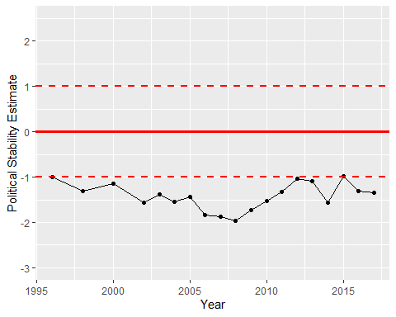

Political Stability Trend